/usr/sbin/groupadd -g 501 oinstall

cut -d: -f1 /etc/group

/usr/sbin/useradd -u 502 -g oinstall –G adm,admin oracle

Passwd oracle

## File System

Create below file system for Oracle products and applications

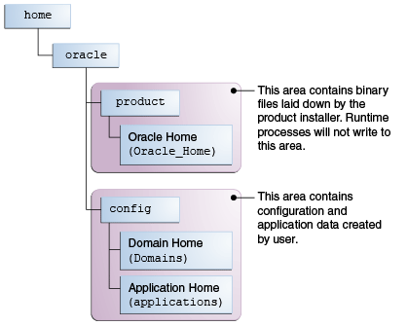

|  |
| --- |
| mkdir -p /home/oracle/products/Oracle_Home  chown oracle:oinstall /home/oracle/products/Oracle_Home  chmod 775 /home/oracle/products/Oracle_Home  mkdir –p /home/oracle/config/domains  chown oracle:oinstall /home/oracle/config/domains  chmod 775 /home/oracle/config/domains  mkdir –p /home/oracle/config/applications  chown oracle:oinstall /home/oracle/config/applications  chmod 775 /home/oracle/config/applications  mkdir –p /home/oracle/products/wlserver12.1.3  chown oracle:oinstall /home/oracle/products/wlserver12.1.3  chmod 775 /home/oracle/products/wlserver12.1.3 |

## Setup Environment variables for oracle user

|  |
| --- |
| vi /home/oracle/.bash_profile  export JAVA_HOME=/home/oracle/products/jdk1.8.0_121  export JRE_HOME=$JAVA_HOME/jre  export CLASSPATH=$JAVA_HOME/lib:$JRE_HOME/lib:WL_HOME%/server/lib:%WL_HOME%/server/liblogic.jar  export WLS_HOME=/home/oracle/products/wlserver12.1.3  export ORACLE_HOME=/home/oracle/products/Oracle_Home  export DOMAIN_HOME=/home/oracle/config/domains  export WL_HOME=$ORACLE_HOME/wlserver  export PATH=$WL_HOME/server/bin:$JAVA_HOME/bin:$JRE_HOME/bin:$HOME/bin:$PATH |

## Install JDK

|  |
| --- |
| tar -xvf /home/oracle/products/ jdk-8u121-linux-x64.tar.gz |

Start Oracle SOA Suite Quick Start Installer

|  |
| --- |
| java -jar fmw_12.2.1.2.0_soa_quickstart_generic.jar |

Standalone Domain

cd *$ORACLE_HOME*/soa/common/bin

QS_TEMPLATES="*$ORACLE_HOME*/soa/common/templates/wls/oracle.soa_template_12.1.3.jar, *$ORACLE_HOME*/osb/common/templates/wls/oracle.osb_template_12.1.3.jar"

export QS_TEMPLATES

./qs_config.sh

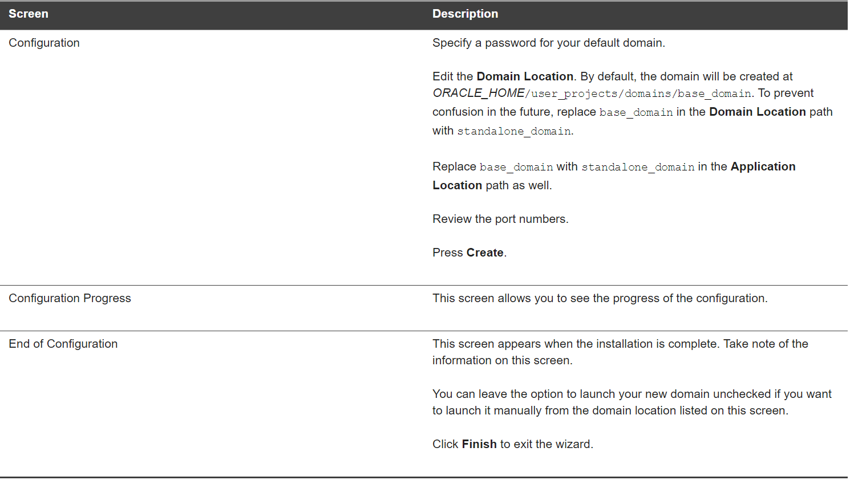

cd *ORACLE_HOME*/jdeveloper/jdev/bin

./jdev

cat /proc/sys/kernel/random/entropy_avail

rngd -r /dev/urandom -o /dev/random -b

EXTRAOPTIONS="-i -r /dev/urandom -o /dev/random -b -t 60 -W 2048"

cd $ORACLE_HOME/jdeveloper/jdev/bin

./jdev

RCU

cd $ORACLE_HOME/oracle_common/bin

./rcu

Compact Domain

cd $ORACLE_HOME/oracle_common/common/bin

setenv CONFIG_JVM_ARGS -Dcom.oracle.cie.config.showProfile=true

export CONFIG_JVM_ARGS

./config.sh